M10.2 Assignment: Ports and Network Tooling Lane Dorscher

Network Ports Explained - Explained
- What is a port and how is it used with an IP address?
A port is a logical communication endpoint used by applications. The IP address identifies the device, and the port number identifies the specific service or application on that device.
- Port 443 is the HTTPS port. Run netstat on your computer. Do you see port 443 used? Take a screen print of your netstat results.
Yes, I do see port 443 being used.
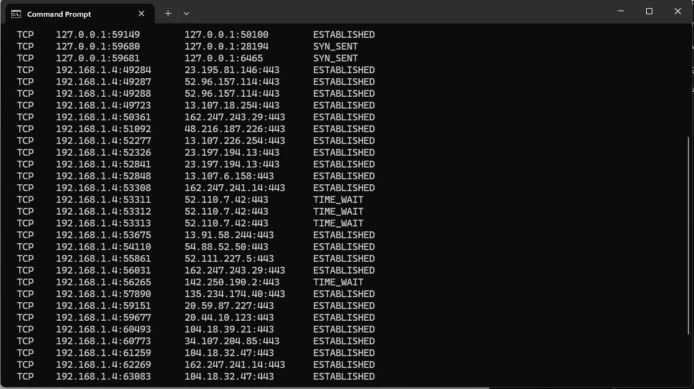
- Explain the difference between the local and foreign address

IPCONFIG - Explained
- Run IPCONFIG on your computer. Is your IP address assigned by DHCP? If so how do you know? Include a screen print of your IPCONFIG command results.
As shown in the screenshot below, the DHCP Enabled says ‘Yes’ and the DHCP Server is shown as well meaning it is enabled.
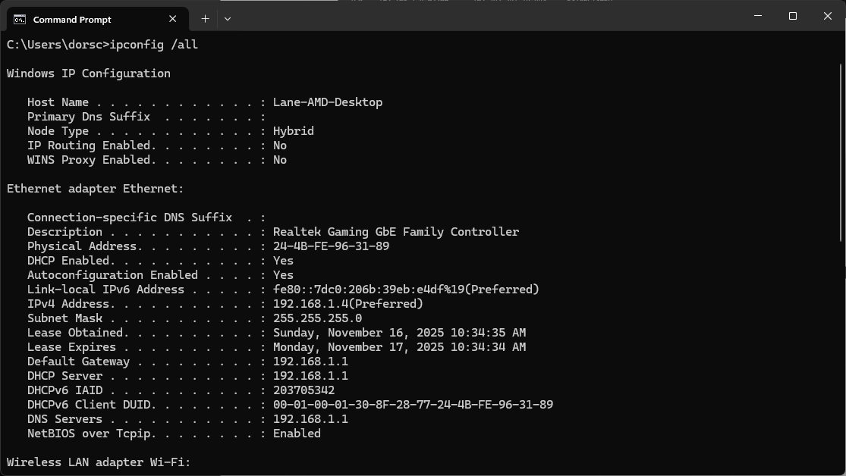
- Go to the website www.whatismyip.com. Does your public IP address listed match your IP address in IPCONFIG? IF not why?
They do not match this is because it only shows the IP address local to my home network. The IP address seen on the internet is the one provided to me by my internet service provider and is used by websites and services on the internet.
- Run IPCONFIG -all. Is your default gateway IP address and DHCP Server IP address the same? If so, what does this mean?
They are the same and this is because my router is acting as the DHCP server AND the gateway to the internet. In a home network, this is appropriate for most consumers whereas businesses may have a separate server to handle IP address assignments.

Task Manager and Port Number - Explained
- What is the PID number for the program listening on port 80 on your computer?
I tried searching for port 80 and did not see anything. Most HTTP is 443. I did see PID number 8000 using the command below.
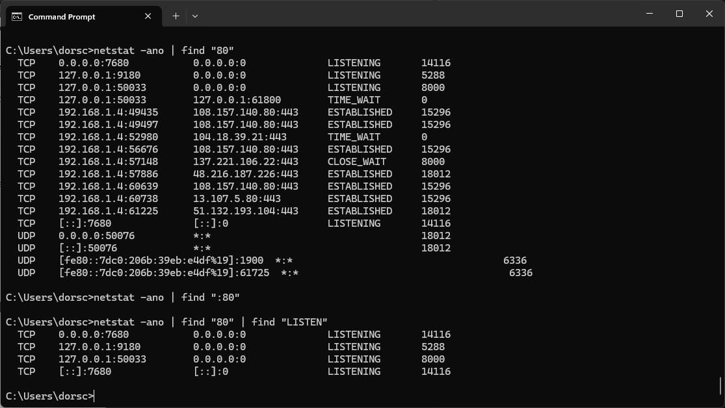
- What is the .exe that is associated with the PID?
The application associated with the PID is called agent.exe.
- What is the description of the .exe?
The description of the application for PID 8000 is that it is a “Battle.net Update Agent” for Blizzard game client.

